
Lesson 10: Play It Again
001 Game Creator (Windows only)
VIDEO GAME CREATION
This week: when the round ends, the game actually stops - and pressing R brings it back to a genuinely fresh start.
Open your own [YourName]Game project from Lesson 9 - don't start a new one.
Tip: no new assets this week - this is a logic lesson, and it reuses your very first setup code from Lesson 5.

Setup
- Open your [YourName]Game project from Lesson 9.
- Create a new Variable (Resources > Variables/Switches/Collections/Tables) named game_active, default value 1.
- Create a new Custom Event (Resources > Custom Events) named ResetGame - this is 001 Game Creator's reusable-subroutine feature, callable from any trigger's script.
- Create a new Input Trigger for the R key (Input Set > Add Control Combination > press R > choose "Pressed" > Edit Script) - the same underlying mechanism your movement and shoot controls have used since Lesson 2.

Level 1 - Minimal (MVP)
When the round ends (win or lose), the game freezes - score and lives stop changing, and further enemy hits/escapes do nothing. Pressing R resets everything and starts a new round.
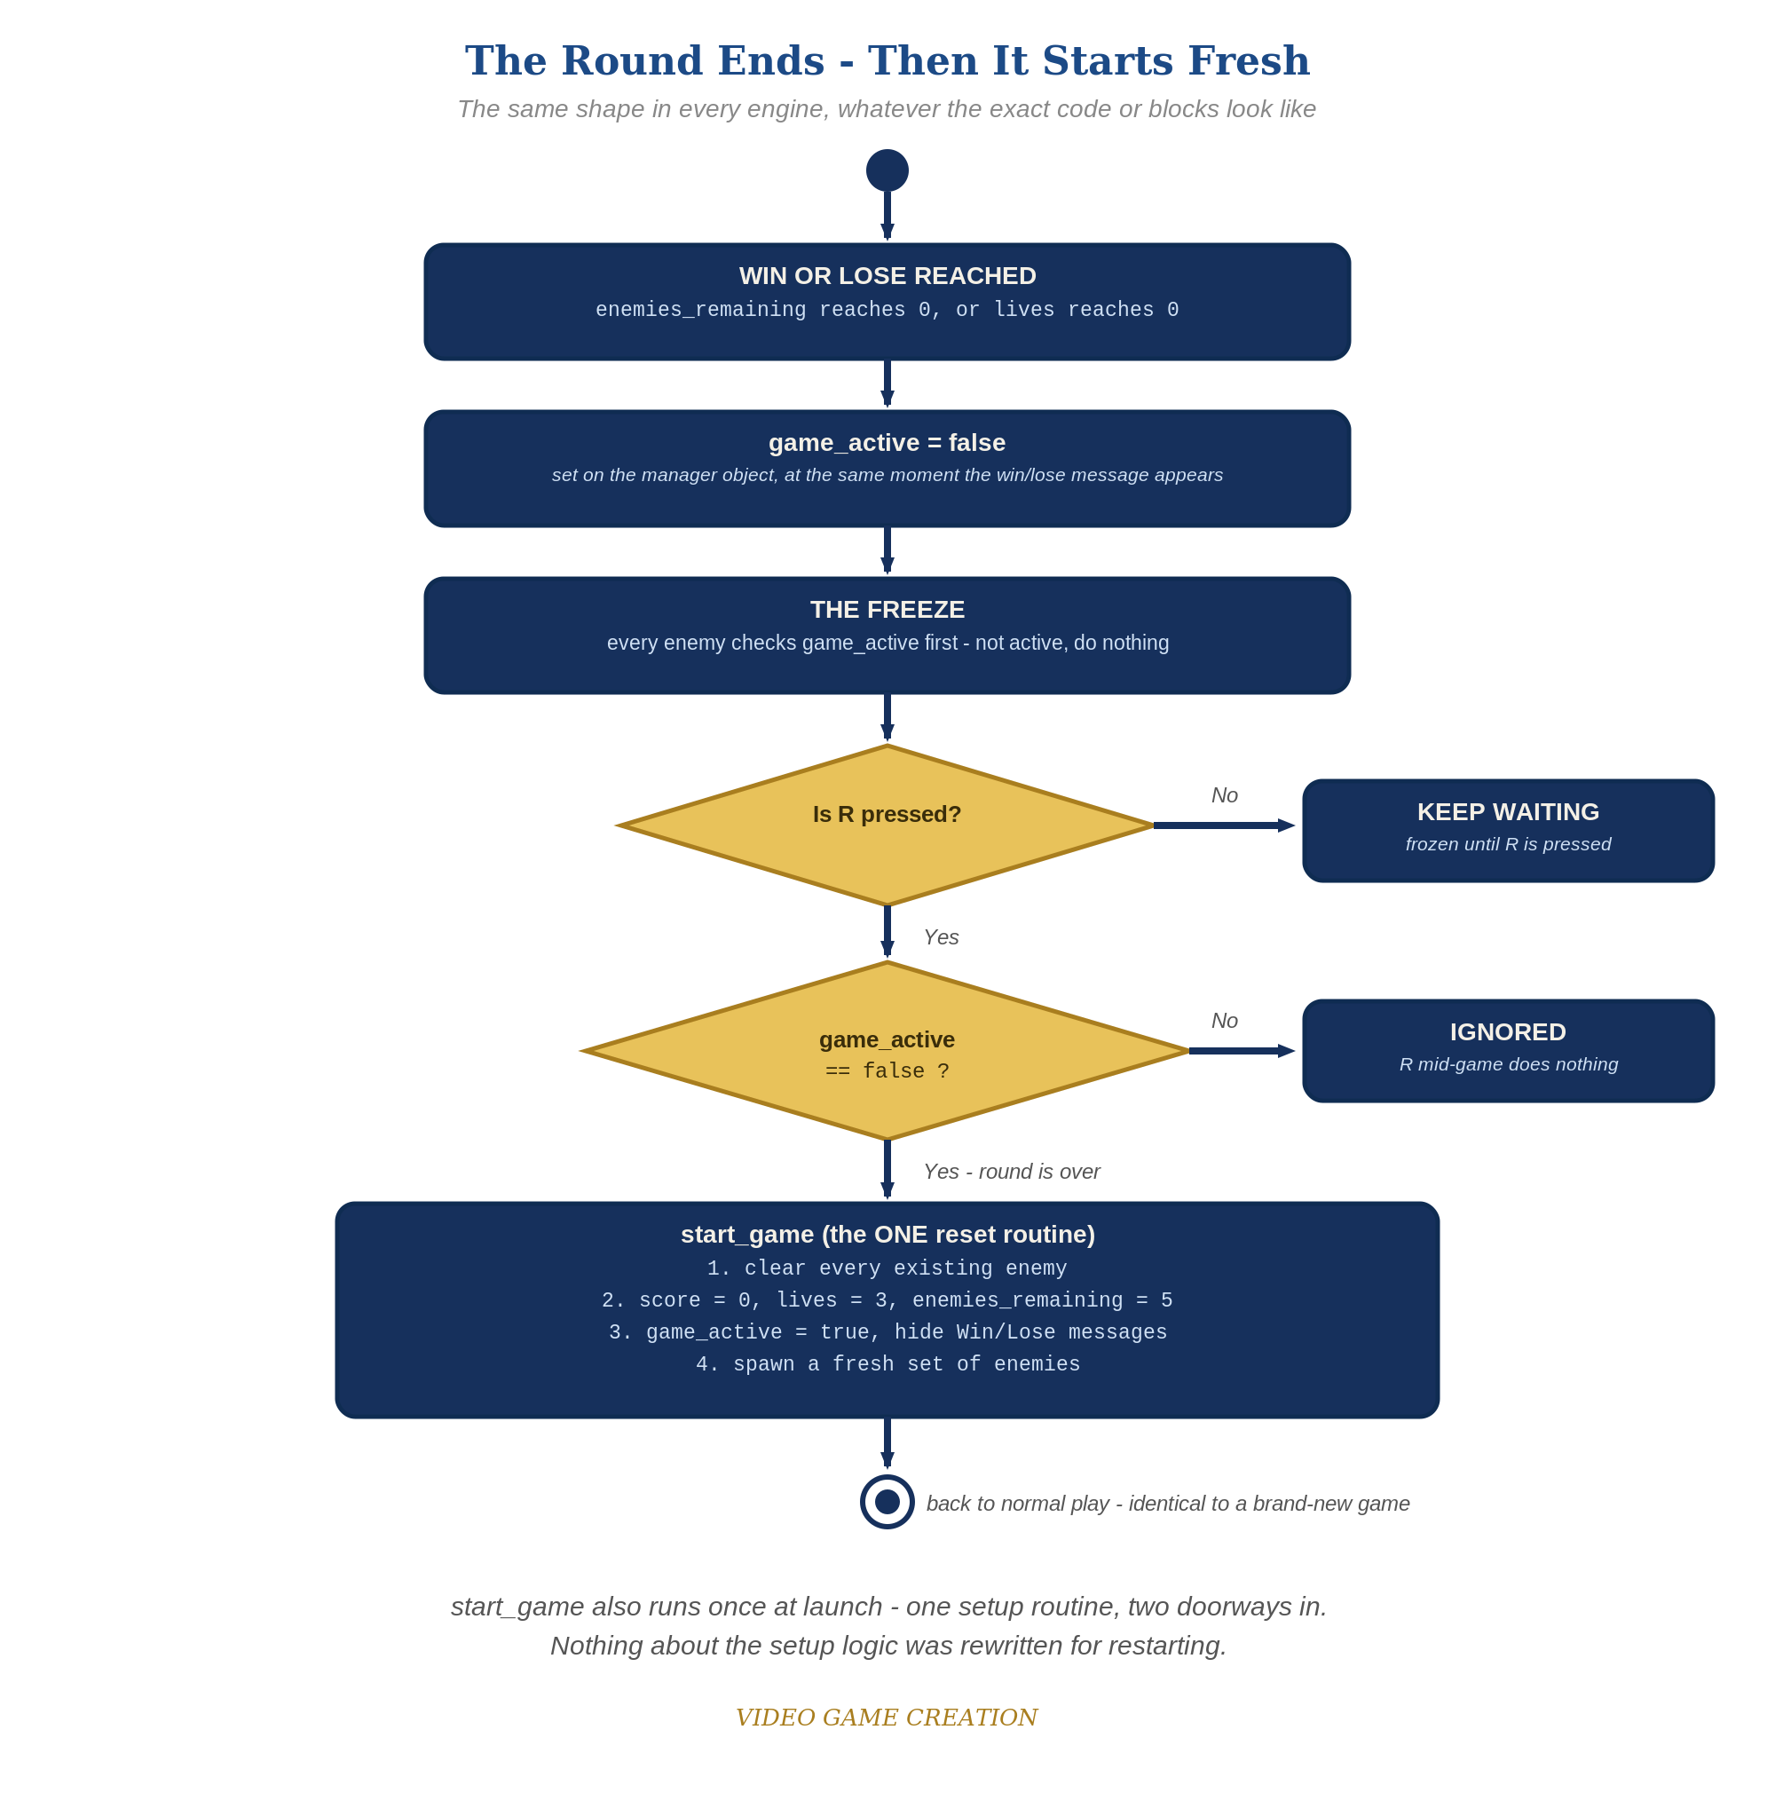
When the round ends, everything freezes - and R, pressed only while the round is over, runs the one reset routine. The same shape in every engine.
- On the enemy Actor Template's "Collided with actor" trigger, wrap the score/enemies_remaining/win-check actions in an If(game_active = 1) check, and when enemies_remaining reaches 0, also set game_active to 0 (code below).
- On the enemy Actor Template's "Left/Entered Camera" trigger, wrap the lives-decrement action in the same If(game_active = 1) check, and when lives reaches 0, also set game_active to 0.
- Update both Message Box texts to include the restart hint: "You Win! - Press R to Restart" and "Game Over - Press R to Restart".
- On your new Input Trigger (R, Pressed), add: If(game_active = 0) -> Call Custom Event(ResetGame).
- Build the ResetGame Custom Event: reset score/lives/enemies_remaining/game_active to their starting values, then revive and reposition each of your enemy copies back to their original starting spots (code below).
- Save, then Play/Test: play to a win or loss, then press R and confirm everything resets and play resumes.
enemy Actor Trigger: Collided with actor (revised) ->
If(game_active = 1)
Variable – Modify Value(score, Add, 10)
Variable – Modify Value(enemies_remaining, Subtract, 1)
If(enemies_remaining <= 0)
Variable – Modify Value(game_active, Set, 0)
Message Box("You Win! - Press R to Restart")
Actor – Destroy/Revive Actor(relate, Destroy)
Actor – Destroy/Revive Actor(this, Destroy)
enemy Actor Trigger: Left/Entered Camera (revised) ->
If(game_active = 1)
Variable – Modify Value(lives, Subtract, 1)
If(lives <= 0)
Variable – Modify Value(game_active, Set, 0)
Message Box("Game Over - Press R to Restart")
Actor – Destroy/Revive Actor(this, Destroy)
Input Trigger: R (Pressed) ->
If(game_active = 0)
Call Custom Event(ResetGame)
Custom Event: ResetGame ->
Variable – Modify Value(score, Set, 0)
Variable – Modify Value(lives, Set, 3)
Variable – Modify Value(enemies_remaining, Set, 5)
Variable – Modify Value(game_active, Set, 1)
Actor – Destroy/Revive Actor(enemy_1, Revive) -> Actor – Teleport(enemy_1, [starting position])
(repeat for enemy_2, enemy_3, enemy_4, enemy_5)

Level 2 - Complete (Alpha/Beta)
A restart is a genuinely clean slate - no leftover enemies, no stale score/lives, and it works correctly no matter how many times in a row you play.
- Play to a win, then press R and confirm score/lives/enemies_remaining are exactly back to 0/3/5, with all 5 enemy copies revived at their starting positions.
- Repeat for a loss - same clean reset.
- Press R while the game is still active and confirm NOTHING happens - the If(game_active = 0) check on your Input Trigger is what prevents an accidental reset.

Level 3 - Refined (Ready to Publish) - pick any that interest you
- Visual: fade the screen briefly (a simple Camera or Interface fade effect, if you're comfortable exploring the wiki further) the moment game_active flips to 0.
- Structure: notice ResetGame is now the single place that sets up a fresh game, callable from your Input Trigger any time it's needed - the same setup values (score, lives, enemies_remaining) only ever need to be written once.
- Design note: because your enemies use Automatic Movement rather than a spawn loop, this lesson intentionally doesn't force-stop enemies already in motion at the moment of game-over - they'll simply drift off naturally within a second or two, harmlessly, since the If(game_active = 1) check means they no longer affect score or lives once the round has ended. This is a deliberate, reasonable simplification for this engine, not a cut corner.

If Something's Wrong
- Restart does nothing when you press R: confirm the Input Trigger's Control Combination is actually set to the R key and "Pressed" (not "Released"), and that game_active is actually 0 at that point.
- Score/lives keep changing after "Game Over": confirm the If(game_active = 1) check was actually added to BOTH triggers (Collided with actor AND Left/Entered Camera), not just one.
- Enemies don't reappear after restart: confirm each enemy copy's exact name (enemy_1, enemy_2, etc.) matches what you use in the ResetGame Custom Event - a typo'd name silently does nothing.

Want More?
001gamecreator.com/wiki/customevents/, 001gamecreator.com/wiki/inputtriggers/, Student Resource List > 001 Game Creator

